Nacton and Bucklesham Under 5’s
The Village Hall
The Street
Nacton
IP10 0EU
Telephone: 014753659809
07845 008081
www.nbu5.co.uk
Prospectus
We will strive to provide an environment, in which children feel happy and secure, encouraging positive attitudes to Learning.
Ofsted visited in February 2016 and gave us a 2 (good).Below is a quote from our latest Ofsted Report:
- The quality of teaching is consistently strong. Staff enthuse and motivate children. They ask questions and respond well to children's suggestions and ideas.
- Staff know children well. They regularly assess what children know and can do and build up an accurate understanding of their capabilities. This helps staff to plan enjoyable and challenging experiences to promote children's good progress.
- Children learn to be independent in their self-care skills. They are enthusiastic as they help prepare snack and confidently get themselves dressed for going outside.
- Children make good progress in their learning given their starting points. Children who have special educational needs are targeted with appropriate interventions to help them achieve to their full potential. (Ofsted Report 2016)

The Report can be viewed in full here>http://reports.ofsted.gov.uk/inspection-reports/find-inspection-report/provider/CARE/251575
Our setting aims to:
- provide high quality care and education for children below statutory school age;
- work in partnership with parents to help children to learn and develop;
- add to the life and well-being of the local community; and
- offer children and their parents a service that promotes equality and values diversity.

Parents
Parents are regarded as members of our setting who have full participatory rights. These include a right to be:
- valued and respected;
- kept informed;
- consulted;
- involved;
- and included at all levels.
As a community based, voluntary managed setting, we also depend on the good will of parents and their involvement to keep going. Membership of the setting carries expectations on parents for their support and commitment.

We aim to ensure that each child:
- is in a safe and stimulating environment;
- is given generous care and attention, because of our ratio of qualified staff to children, as well as volunteer parent helpers;
- has the chance to join with other children and adults to live, play, work and learn together;
- is helped to take forward her/his learning and development by being helped to build on what she/he already knows and can do;
- has a personal key person who makes sure each child makes satisfying progress;
- is in a setting that sees parents as partners in helping each child to learn and develop;
- and is in a setting in which parents help to shape the service it offers.
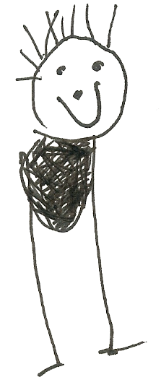

Children learn as they play. Most importantly, in play children learn how to learn.

Children's development and learning
Learning through play

Play helps young children to learn and develop through doing and talking, which research has shown to be the means by which young children learn to think. Children are motivated by their need to know more, to explore, question, think, imagine, create, express and communicate. We frequently encourage and support these activities. We see the role of play as essential to learning at this age. Our setting uses the practice guidance to plan and provide a range of play activities which help children to make progress in each of the areas of learning and development. In some of these activities children decide how they will use the activity and, in others, an adult takes the lead in helping the children to take part in the activity. In all activities information from the practice guidance has been used to decide what equipment to provide and how to provide it.

The provision for children's development and learning is guided by The Early Years Foundation Stage Framework (2014).
Our provision reflects the four key themes of the Early Years Foundation Stage.
A Unique Child
Every child is a unique child who is constantly learning and can be resilient, capable, confident and self-assured.
Practitioners
- understand and observe each child’s development and learning, assess progress, plan for next steps
- and children to develop a positive sense of their own identity and culture
- identify any need for additional support
- keep children safe
- value and respect all children and families equally
Positive Relationships
Children learn to be strong and independent through positive relationships.
Positive relationships are
• warm and loving, and foster a sense of belonging
• sensitive and responsive to the child’s needs, feelings and interests
• supportive of the child’s own efforts and independence
• consistent in setting clear boundaries
• stimulating
• built on key person relationships in early years settings
Enabling Environments

Children learn and develop well in enabling environments, in which their experiences respond to their individual needs and there is a strong partnership between practitioners and parents and carers.
Enabling Environments
• value all people
• value learning
They offer
• stimulating resources, relevant to all the children’s cultures and communities
• rich learning opportunities through play and playful teaching
• support for children to take risks and explore
Learning and Development
Children develop and learn in different ways. The framework covers the education and care of all children in early years provision, including children with special educational needs and disabilities. Practitioners teach children by ensuring challenging, playful opportunities across the prime and specific areas of learning and development.
They foster the characteristics of effective early learning
• Playing and exploring
• Active learning
• Creating and thinking critically

How we provide for development and learning
Children are born ready, able and eager to learn. They actively reach out to interact with other people, and in the world around them. Development is not an automatic process, however. It depends on each unique child having opportunities to interact in positive relationships and enabling environments.
The care and education offered by our setting helps children to continue to do this by providing all of the children with interesting activities that are appropriate for their age and stage of development.

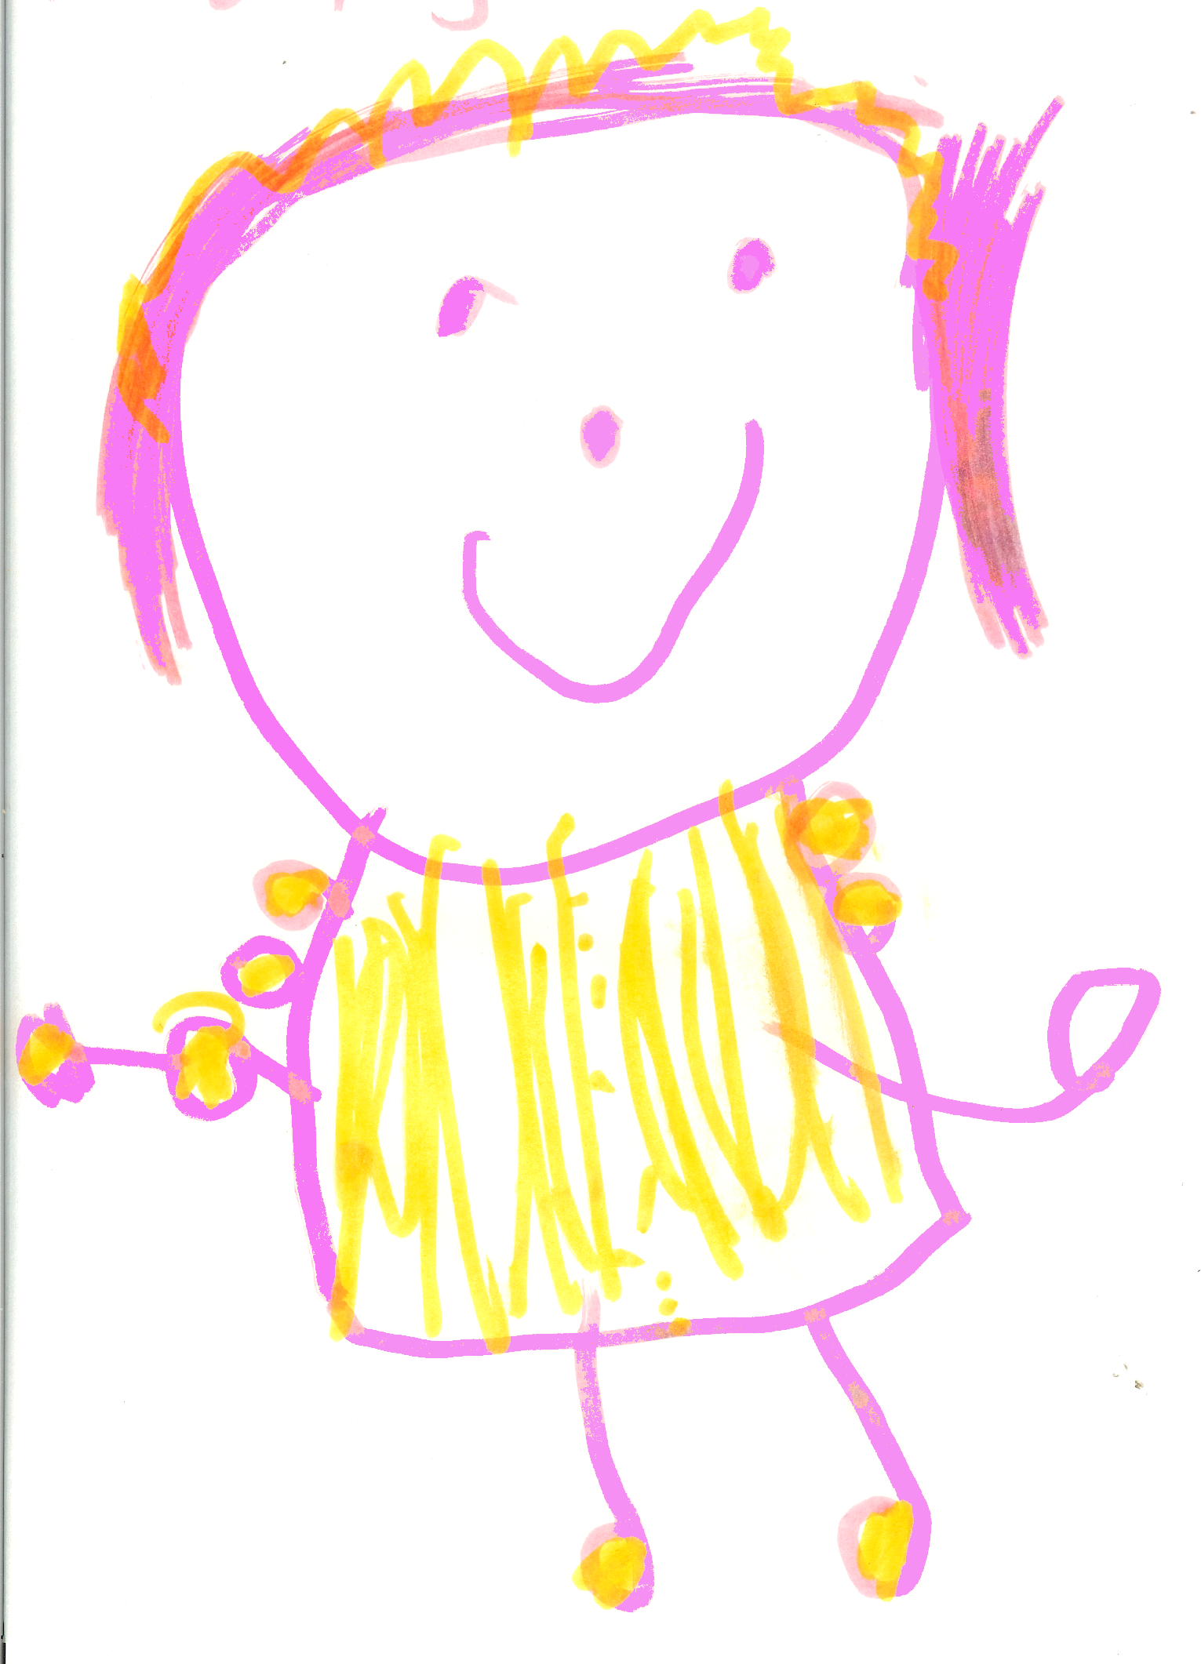
The Areas of Development and Learning comprise:
prime areas:
• Communication and Language;
• Physical Development;
• Personal, Social and Emotional Development.
specific areas:
• Literacy;
• Mathematics;
• Understanding the World;
• Expressive Arts and Design.

The ways in which the child engages with other people and their environment – Playing and Exploring, Active Learning, and Creating and Thinking Critically – underpin learning and development across all areas and support the child to remain an effective and motivated learner.

The prime areas begin to develop quickly in response to relationships and experiences, and run through and support learning in all other areas. The prime areas continue to be fundamental throughout the EYFS.

The prime areas
Communication and Language development involves giving children opportunities to experience a rich language environment; to develop their confidence and skills in expressing themselves; and to speak and listen in a range of situations.
- Listening and attention: children listen attentively in a range of situations. They listen to stories, accurately anticipating key events and respond to what they hear with relevant comments, questions or actions. They give their attention to what others say and respond appropriately, while engaged in another activity.
- Understanding: children follow instructions involving several ideas or actions. They answer ‘how’ and ‘why’ questions about their experiences and in response to stories or events.
- Speaking: children express themselves effectively, showing awareness of listeners’ needs. They use past, present and future forms accurately when talking about events that have happened or are to happen in the future. They develop their own narratives and explanations by connecting ideas or events.
Physical Development involves providing opportunities for young children to be active and interactive; and to develop their co-ordination, control, and movement. Children must also be helped to understand the importance of physical activity, and to make healthy choices in relation to food
- Moving and handling: children show good control and co-ordination in large and small movements. They move confidently in a range of ways, safely negotiating space. They handle equipment and tools effectively, including pencils for writing.
- Health and self-care: children know the importance for good health of physical exercise, and a healthy diet, and talk about ways to keep healthy and safe. They manage their own basic hygiene and personal needs successfully, including dressing and going to the toilet independently.
Personal, Social and Emotional development involves helping children to develop a positive sense of themselves, and others; to form positive relationships and develop respect for others; to develop social skills and learn how to manage their feelings; to understand appropriate behaviour in groups; and to have confidence in their own abilities.
- Self-confidence and self-awareness: children are confident to try new activities, and say why they like some activities more than others. They are confident to speak in a familiar group, will talk about their ideas, and will choose the resources they need for their chosen activities. They say when they do or don’t need help.
- Managing feelings and behaviour: children talk about how they and others show feelings, talk about their own and others’ behaviour, and its consequences, and know that some behaviour is unacceptable. They work as part of a group or class, and understand and follow the rules. They adjust their behaviour to different situations, and take changes of routine in their stride.
- Making relationships: children play co-operatively, taking turns with others. They take account of one another’s ideas about how to organise their activity. They show sensitivity to others’ needs and feelings, and form positive relationships with adults and other children.

The specific areas include essential skills and knowledge. They grow out of the prime areas, and provide important contexts for learning.

The specific areas
Literacy development involves encouraging children to link sounds and letters and to begin to read and write. Children must be given access to a wide range of reading materials (books, poems, and other written materials) to ignite their interest.
- Reading: children read and understand simple sentences. They use phonic knowledge to decode regular words and read them aloud accurately. They also read some common irregular words. They demonstrate understanding when talking with others about what they have read.
- Writing: children use their phonic knowledge to write words in ways which match their spoken sounds. They also write some irregular common words. They write simple sentences which can be read by themselves and others. Some words are spelt correctly and others are phonetically plausible.
Mathematics involves providing children with opportunities to develop and improve their skills in counting, understanding and using numbers, calculating simple addition and subtraction problems; and to describe shapes, spaces, and measures.
- Numbers: children count reliably with numbers from 1 to 20, place them in order and say which number is one more or one less than a given number. Using quantities and objects, they add and subtract two single-digit numbers and count on or back to find the answer. They solve problems, including doubling, halving and sharing.
- Shape, space and measures: children use everyday language to talk about size, weight, capacity, position, distance, time and money to compare quantities and objects and to solve problems. They recognise, create and describe patterns. They explore characteristics of everyday objects and shapes and use mathematical language to describe them.
Understanding the World involves guiding children to make sense of their physical world and their community through opportunities to explore, observe and find out about people, places, technology and the environment.
- People and communities: children talk about past and present events in their own lives and in the lives of family members. They know that other children don’t always enjoy the same things, and are sensitive to this. They know about similarities and differences between themselves and others, and among families, communities and traditions.
- The world: children know about similarities and differences in relation to places, objects, materials and living things. They talk about the features of their own immediate environment and how environments might vary from one another. They make observations of animals and plants and explain why some things occur, and talk about changes.
- Technology: children recognise that a range of technology is used in places such as homes and schools. They select and use technology for particular purposes.
Expressive Arts and design involves enabling children to explore and play with a wide range of media and materials, as well as providing opportunities and encouragement for sharing their thoughts, ideas and feelings through a variety of activities in art, music, movement, dance, role-play, and design and technology.
- Exploring and using media and materials: children sing songs, make music and dance, and experiment with ways of changing them. They safely use and explore a variety of materials, tools and techniques, experimenting with colour, design, texture, form and function.
- Being imaginative: children use what they have learnt about media and materials in original ways, thinking about uses and purposes. They represent their own ideas, thoughts and feelings through design and technology, art, music, dance, role-play and stories.

Our approach to learning, development and assessment
We assess how young children are learning and developing by observing them frequently. We use the information that we gain from observations, as well as from photographs of the children, to document their progress and where this may be leading them. We believe that parents know their children best and we ask them to contribute to assessment by sharing information about what their children like to do at home and how they as parents are supporting development.

We make periodic assessment summaries of children’s achievement based on our on-going development records. These form part of children’s records of achievement- Their Learning Journey. We undertake these assessment summaries once a term as well as at times of transition, such as when a child moves to a different Setting or when they go on to School.

Records of achievement- Learning Journey
The setting keeps a record of achievement for each child. Staff and parents working together on their children's records of achievement is one of the ways in which the key person and parents work in partnership. Your child's Learning Journey helps us to celebrate together their achievements and to work together to provide what your child needs for their well-being and to make progress. Your child's key person will keep this record. To do this you and she will collect information about your child's needs, activities, interests and achievements. This information will enable the key person to identify your child's stage of progress and preferred learning style..

Working together for your children
In our setting we maintain the ratio of adults to children in the setting that is set through the Welfare Requirements. We also have volunteer parent helpers where possible to complement these ratios. This helps us to:
- give time and attention to each child;
- talk with the children about their interests and activities;
- help children to experience and benefit from the activities we provide;
- and allow the children to explore and be adventurous in safety.

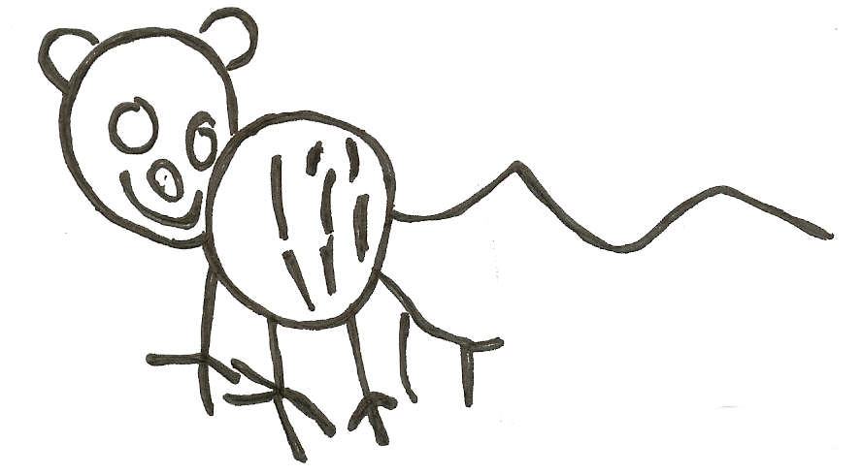

The staff who work at our setting are:

Name | Job Title | Qualifications and Experience
Meryl Taverner | Play Leader | B.Ed. (Hons.) (11-16yr Art & Design) QTS-.
Sue Winder | Play Leader & SENCo | SENCo, NNEB .
Kate Bingham | Administrator / Play Worker | NVQ3- working towards a degree in Early Childhood Education
Taryn Tye | Play Worker | BA in Early Childhood Education
Christine Tattersall | Play Worker | C.Ed. – (11-16yr P.E., Primary teacher & tutor for Early Years) QTS-
Kirsten Ault | Play Worker | Working towards a degree in Early childhood education
Michelle Frost | Play Worker | NVQ2-.working towards a level 3 .
Kate Whelan | Play Worker | NVQ2
Zoe Saxton | Play Worker | BA (Hons) (English) PGCE (Primary education) QTS  Taught in local primary schools.

About the Playgroup

We are a small friendly pre-school playgroup, established in 1977, open each weekday during term-time, based at the Village Hall in Nacton. We are fortunate to be situated in beautiful countryside and like to explore the locality by going for walks in the woods, walking to the local farm fields to watch planting and harvesting, looking for signs of the season such as icy puddles, frost, spring flowers, conker collecting and the changing colour of leaves. We also visit the local shop, Victoria field and the sports field.
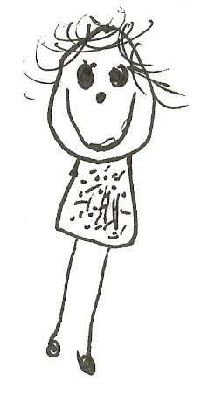
- We are open for 38 weeks each year, 5 days a week
- Playgroup is open to children from age 2 up to age 5.
- Sessions run each weekday morning from 9.15am to 12.15pm
- 12.15pm to 3-15pm on a Tuesday- (This is for 4 year olds only.)

How parents take part in the setting
Our setting recognises parents as the first and most important educators of their children. All of the staff see themselves as partners with parents in providing care and education for their child. There are many ways in which parents take part in making the setting a welcoming and stimulating place for children and parents, such as:
- exchanging knowledge about their children's needs, activities, interests and progress with the staff;
- helping out at sessions as a parent Helper each half term or more regularly;
- sharing their own special interests with the children;
- helping to provide, make and look after the equipment and materials used in the children's play activities;
- being part of the management of the setting;
- taking part in events and informal discussions about the activities and curriculum provided by the setting;
- joining in community activities in which the setting takes part; and
- building friendships with other parents in the setting.

The parents' rota
One parent/carer of every child will be asked to help for at least two mornings per term. Parents are asked to sign a rota each term, and if you find you are unable to be on duty on your morning, we ask that you do find someone either to swap with you, or to stand in for you, and to let us know in advance that you have done this. Helping at the session enables parents to see what the day-to-day life of the setting is like and to join in helping the children to get the best out of their activities.
Joining in
Joining the rota is not the only means of taking part in the life of the setting. Parents can offer to take part in a session by sharing their own interests and skills with the children. Parents have visited the setting to do drama, singing, cook with the children (We have had Kenyan, Polish and German recipes taught to us), give us surplus plants and help in the garden, and show the children newts, guinea pigs, baby rabbits and a puppy….or just play with us in the woods, helping us to identify plants, birds and wild life tracks. We welcome parents to drop into the setting to see it at work or to speak with the staff.
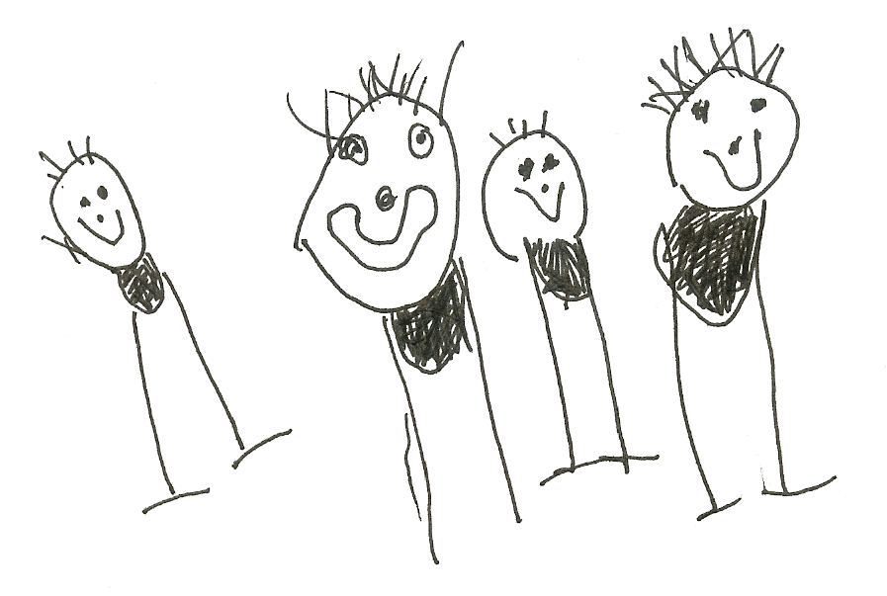

Learning opportunities for adults
As well as gaining qualifications in early years care and education, the setting staff take part in further training to help them to keep up-to-date with thinking about early years care and education.
The setting also keeps itself up-to-date with best practice in early years care and education by accessing courses run by Suffolk County Council, as a member of the Pre-school Learning Alliance, through the Under 5 magazine and publications produced by the Alliance. The current copy of Under Five is available for you to read, it can be located in the lobby.

The setting's timetable and routines
Our setting believes that care and education are equally important in the experience which we offer children. The routines and activities that make up the day in the setting are provided in ways that:
- help each child to feel that she/he is a valued member of the setting;
- ensure the safety of each child;
- help children to gain from the social experience of being part of a group; and
- provide children with opportunities to learn and help them to value learning.

The session
We organise our sessions so that the children can choose from, and work at, a range of activities and, in doing so, build up their ability to select and work through a task to its completion. The children are also helped and encouraged to take part in adult-led small and large group activities which introduce them to new experiences and help them to gain new skills, as well as helping them to learn to work with others. Outdoor activities contribute to children's health, their physical development and their knowledge of the world around them. The children have the opportunity, and are encouraged, to take part in outdoor child-chosen and adult-led activities, as well as those provided in the indoor playroom(s).

Snacks
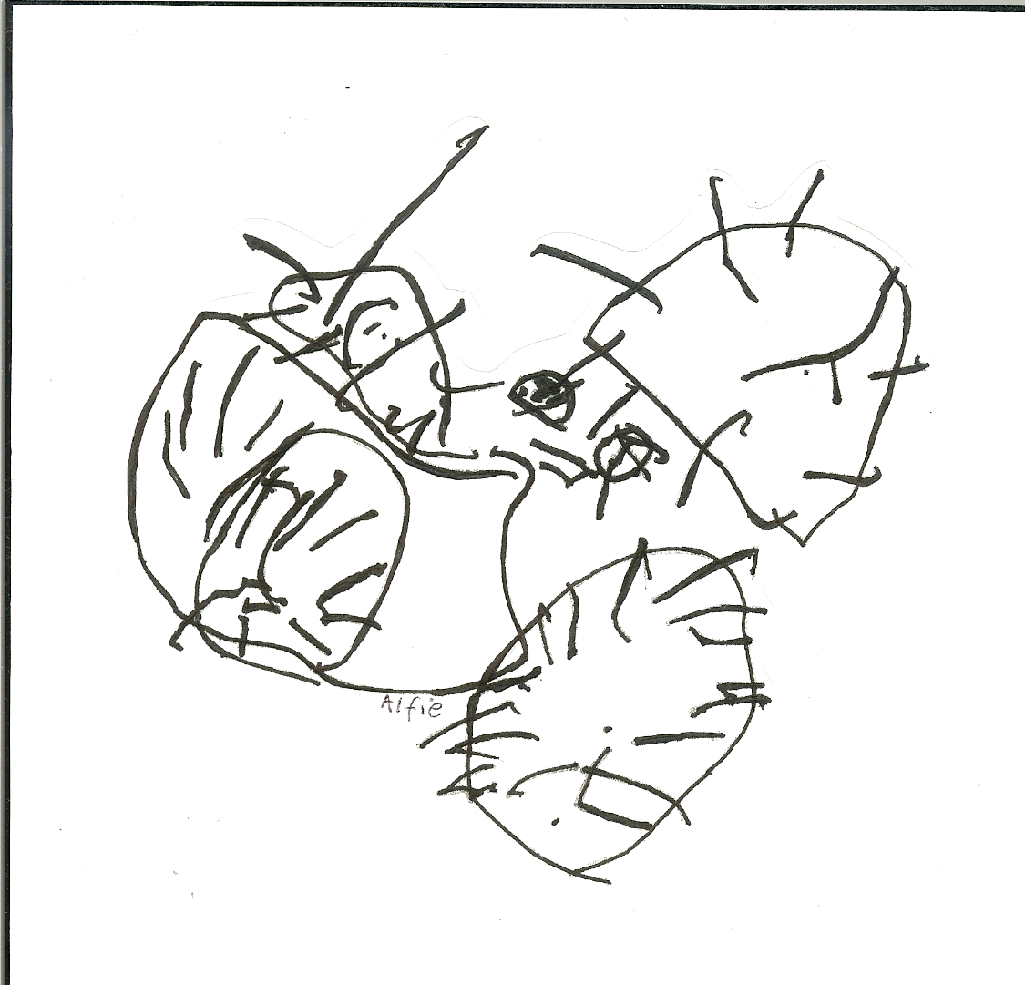
The setting makes snack-times a social time for children and adults to eat together. We plan the menus for snack so that the children have healthy and nutritious food. Do tell us about your child's dietary needs and we will make sure that these are met.

Policies
The setting's policies and procedures are available for you to see here http://www.nbu5.co.uk/downloads/Policies%202015b.zip or at the setting, please ask a member of staff if you wish to see a copy. A brief outline of some of the policies is provided with this pack. The setting's policies help us to make sure that the service provided is a high quality one. The staff and parent run committee work together to adopt the policies, and then annually review them. This review helps us to make sure that the policies are enabling the setting to provide a quality service for its members and the local community.
Safeguarding children
Our setting has a duty under the law to help safeguard children against suspected or actual ‘significant harm’. Our employment practices ensure children against the likelihood of abuse in our settings and we have a procedure for managing complaints or allegations against a member of staff. Our way of working with children and their parents ensures we are aware of any problems that may emerge and can offer support, including referral to appropriate agencies when necessary, to help families in difficulty.

Special needs
As part of the setting's policy to make sure that its provision meets the needs of each individual child, we take account of any special needs a child may have. The setting works to the requirements of the Early Years Foundation Stage and the Disability Discrimination Act (DCSF 2010) and The Special Educational Needs and Disability Code of Practice (2014). Our Special Educational Needs Co-ordinator is Sue Winder.

The management of our setting
A parent management committee - whose members are elected by the parents of the children who attend the setting - manages the setting. The elections take place at our Annual General Meeting. The committee is responsible for:
- managing the setting's finances;
- employing and managing the staff;
- making sure that the setting has, and works to, policies that help it to provide a high quality service; and
- making sure that the setting works in partnership with the children's parents.

The Annual General Meeting is open to the parents of all of the children who attend the setting. It is our shared forum for looking back over the previous year's activities and shaping the coming year's plan.

Fees
For your child to keep her/his place at the setting, you must pay the fees. We are in receipt of nursery education funding for two, three and four year olds from the term after they turn three; where funding is not received, then fees apply. Snack/cooking ingredient fees are not funded.

Fees must still be paid if children are absent without notice for a short period of time. If your child has to be absent over a long period of time, talk to the committee chairperson or one of the Play Leaders.

Starting at our setting
The first days
We want your child to feel happy and safe with us. To make sure that this is the case, the staff will work with you to decide on how to help your child to settle into the setting. The setting has a policy about helping children to settle into the setting: a copy is enclosed in this Starter pack or is available from one of the Play Leaders.

Clothing
We provide protective clothing for the children when they play with messy activities. We encourage children to gain the skills that help them to be independent and look after themselves. These include taking themselves to the toilet and taking off, and putting on, outdoor clothes. Clothing that is easy for them to manage will help them to do this.

The staff are always ready and willing to talk with you about your ideas, views or questions. We hope that you and your child enjoy being members of our setting and that you both find taking part in our activities interesting and stimulating.

